Task No: 16  Date:31/10/25 | Messaging using PySpark and Hive | CO4  K3

AIM: To Build a Data Pipeline based on Messaging using PySpark and Hive.
PROCEDURE:
Step 1: Create a Spark session
Step 2: Ingest data from a source (e.g., CSV file)
Step 3: Data Transformation and Cleaning (e.g., filtering)
Step 4: Write data to HDFS (e.g., Parquet format)
Step 5: Create a Hive External Table
Step 6: Query and analyze data with Hive
Step 7: Stop the Spark session
CODE:
from pyspark.sql import SparkSession
spark = SparkSession.builder.appName("DataPipeline").getOrCreate()
source_data = spark.read.csv("source_data.csv", header=True, inferSchema=True)
cleaned_data = source_data.filter(source_data["column_name"] > 10)
cleaned_data.write.mode("overwrite").parquet("hdfs:///user/hive/warehouse/cleaned_data")
spark.sql("""
CREATE EXTERNAL TABLE cleaned_data (
col1 STRING,
col2 INT
)
ROW FORMAT SERDE 'org.apache.hadoop.hive.ql.io.parquet.serde.ParquetHiveSerDe'
STORED AS INPUTFORMAT 'org.apache.hadoop.mapred.SequenceFileInputFormat'
OUTPUTFORMAT 'org.apache.hadoop.hive.ql.io.HiveSequenceFileOutputFormat'
LOCATION 'hdfs:///user/hive/warehouse/cleaned_data'
"")

# You can now use Hive to run SQL queries on the data in the "cleaned_data" external table.
spark.stop()

IMPLEMENTATION:
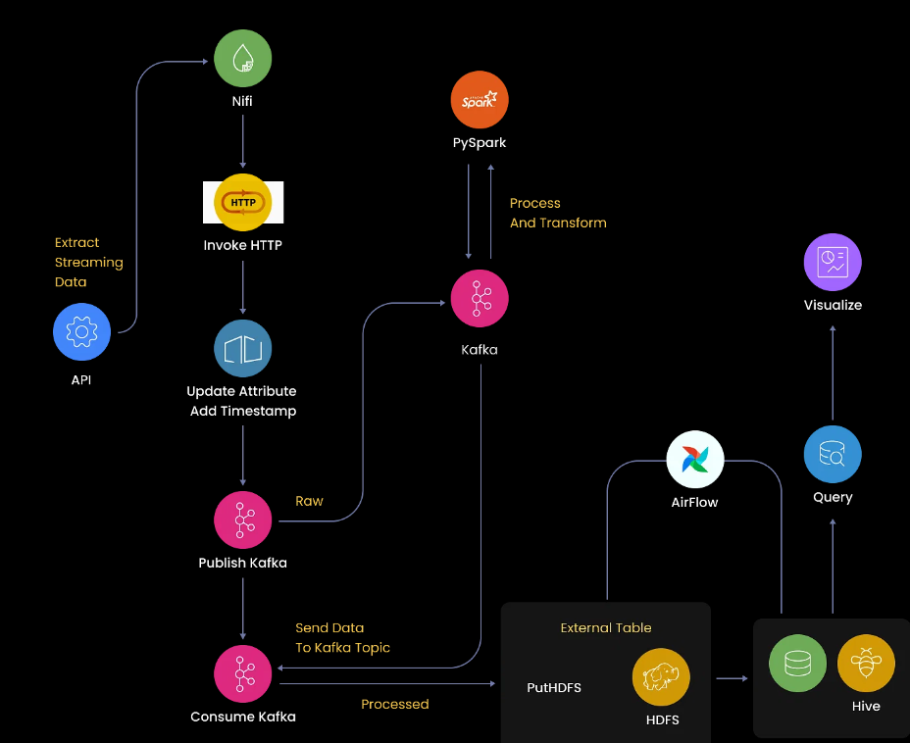

RESULT:Thus to build a Data Pipeline based on Messaging using PySpark and Hive was executed successfully.

